# **Name: Abdurrahman Qureshi**

# **Roll No: 242466**

Assignment No: 1

Date Of Performance: 10/08/2025

Aim: AWS Academy - Cloud Foundations

Knowledge check score of Module 1, Module 2 and Module 3

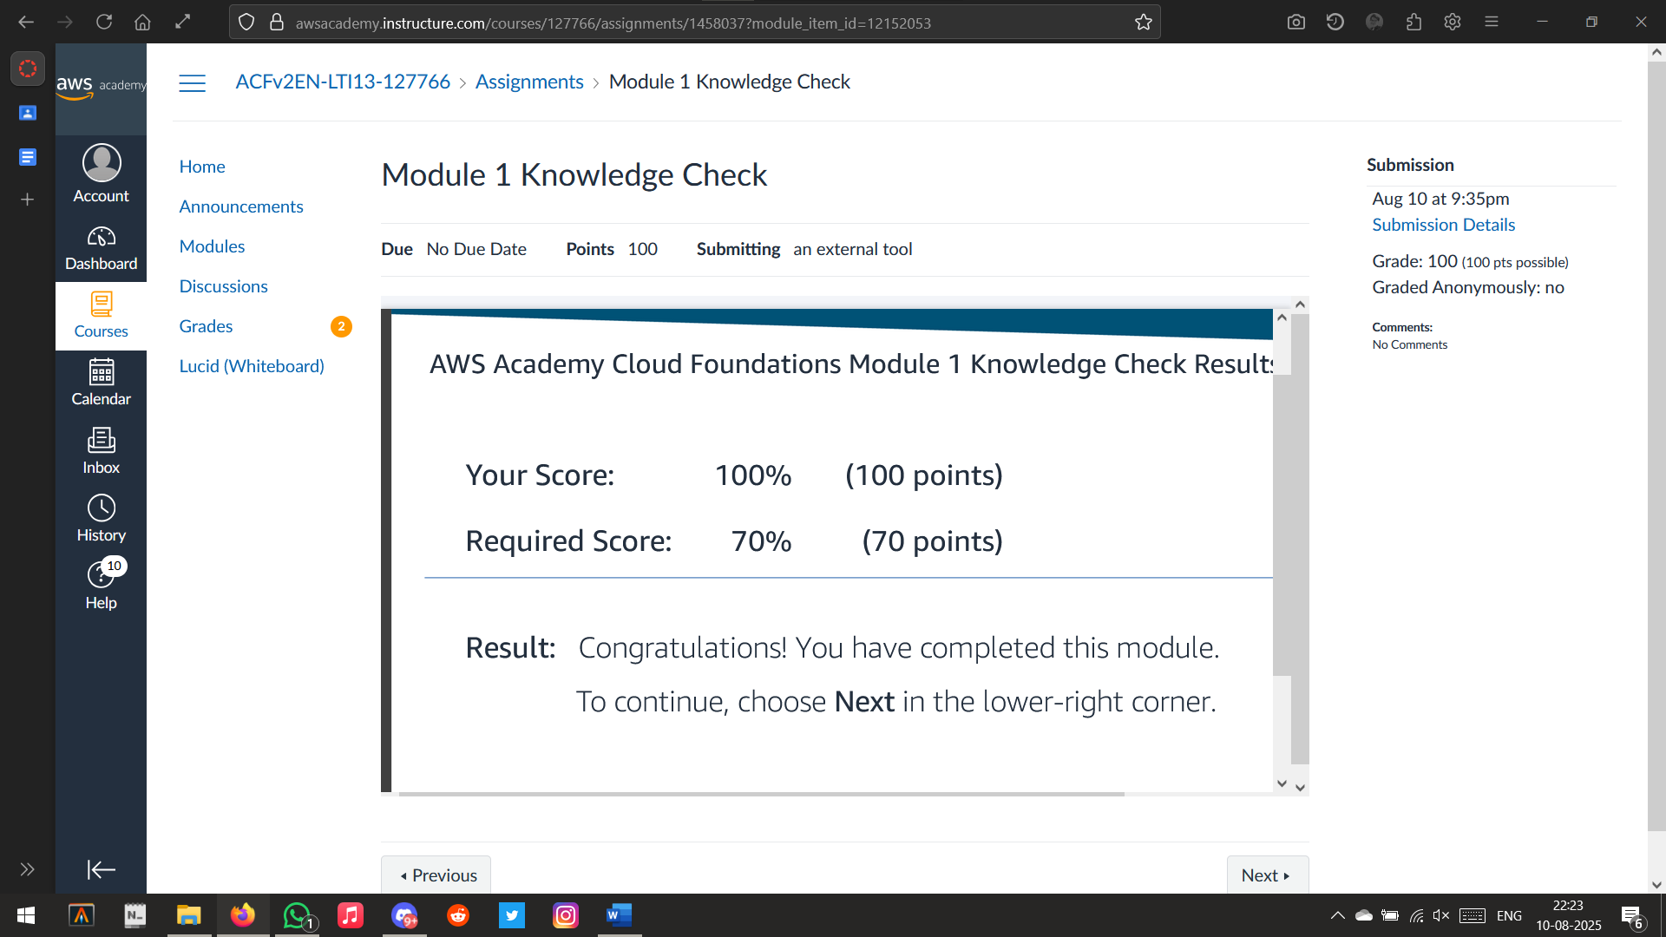

Module 1

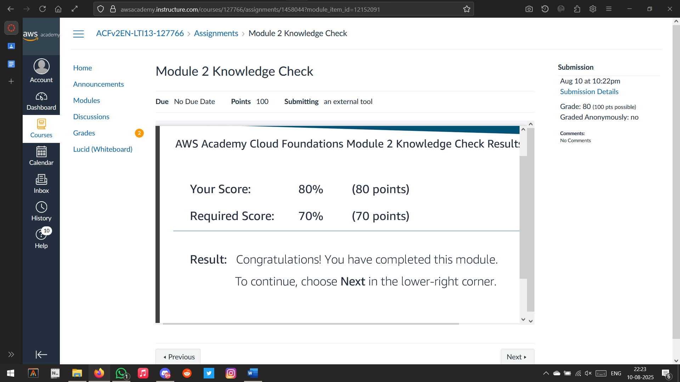

Module 2

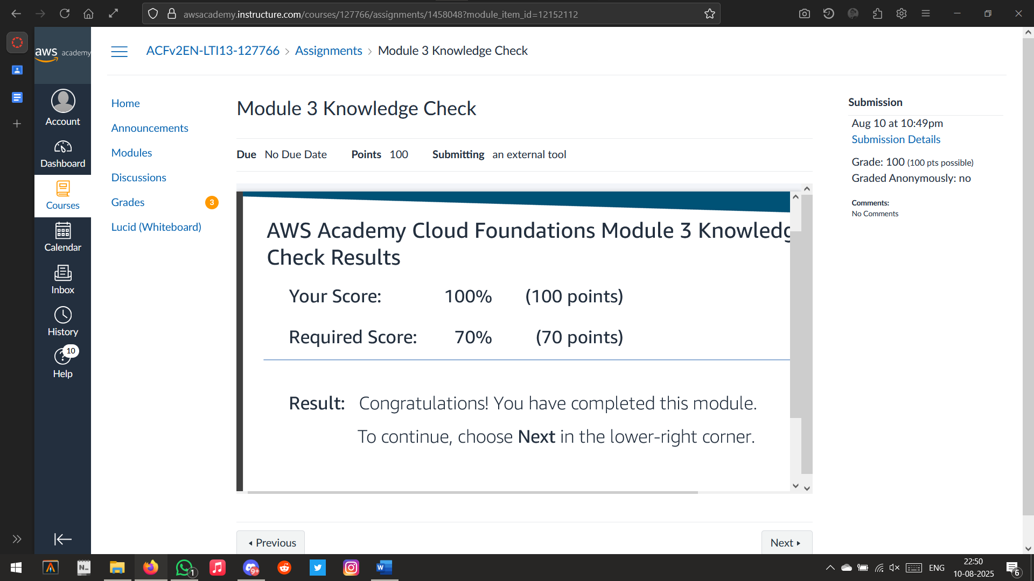

Module 3